

SEDL 8214
Manual Price Report
should not trigger STOP order

Test Plan Document

Prepared by: Mike Hasbrouck

Table OF contents

Test Setup Instructions: 3
1. Trading Properties 3
2. Routing Properties 3
Test1. STOP order rests in book, Manuel Price Report entry should not trigger the STOP order 4

Test Setup Instructions:

Properties Settings

DEFAULT Setting to be used by all Test Case (unless explicitly specified)
- Use a class with a Product Description of ‘EQUITY D PENNIES ALL’

1. Trading Properties
- ‘Auction Enabled for New Hal (-8)’ = True
- ‘Allowed HAL Origin Codes’ = False for C, M, F, A, P
- ‘Auto Link Origin Codes’ = True for C, M, F, A, P
- ‘Allow Market Order’ = True

2. Routing Properties
- ‘Help Desk Default Destination’ = <OMT User> (ex. HOMT1)
- ‘Firm Volume Limit Simple Order’ = 4999
- ‘Volume Deviation Check Simple Orders’ = 4999, Level = 1, Deviation = All

Test1. STOP order rests in book, Manuel Price Report entry should not trigger the STOP order

# | Action | Input Values | Expected Results
1 | Set Product State to ‘Open’ from SA GUI | ➔ | - Product is in ‘Open’ State
2 | MM1 Enters Quote on Product | Bid: $1.00 X 1000  Ask: $1.20 X 1000
  Exchange: | Bid: | Ask:
  CBOE | 1.00x1000 | 1.20x1000
3 | Enter some trades on the product |  | - A LATE prefix cannot be entered on the first trade of the day
4 | Enter STOP Order on Product using Gui | ORD1: Sell 20@1.10, Origin=’C’, Contingency STP | - ORD1 is in waiting state, but will not appear in book depth
4 | Using a Price Reporter gui, submit a Manuel Price with a LATE prefix, which is below the STOP order price | 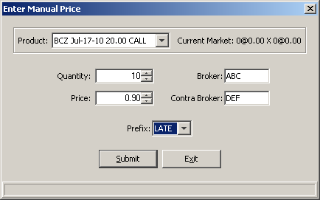 | - Manual Price accepted and Last Sale prefix displays LATE
5 | Check gui | ➔ | - LATE prefix and price should be displayed in Last Sale column
6 | Enter an Order to trade with sell side quote | ORD2: Buy 20@MKT, Origin=’C’ | - ORD2 trades 20 with quote at 1.20
7 | Enter an Order to trade with buy side quote | ORD3: Sell 20@MKT, Origin=’C’ | - ORD3 trades 20 with quote at 1.00
8 | STOP Order should trigger |  | - ORD1 STOP order starts auction and trades with buy side quote 20 @ 1.00
9 | Check Current Market
  Exchange: | Bid: | Ask:
  CBOE | 1.00x960 | 1.20x980

